**Introduction to SQL**

**Introduction to SQL and Its Data Type**

SQL (Structured Query Language) is a standard programming language specifically for managing and manipulating relational databases. It is used to create, read, update to create, read, update, and delete data in a structured way.

SQL data types help define the kind of data that can be stored in each column of a table. Here are some common SQL data type:

1. **Numeric Data Types**

* **INT:** Integer number, e.g., 1, 100, -20.
* **DECIMAL(p, s)** or **NUMERIC:** Fixed precision number with specified digits after the decimal.
* **FLOAT** and **REAL:** For floating – point number (decimal number with variable precision ).

1. **Character Data Types**

* **CHAR(n):** Fixed-length string (e.g, CHAR(10)reserve 10 characters).
* **VARCHAR(n):** Variable-length strings (e.g., VARCHAR(50) allows up to 50 characters).
* **TEXT:** Large amount of text.

1. **Date and Time Data Types**

* **Date:** Stores data values (year, month, day).
* **Time:** Stores time values (hours, minutes, seconds).
* **DATETIME:** Store date and time with time zone info.

1. **Boolean Data Types**

* **BOOLEAN:** Stores true/false values.

1. **Binary Data Types**

* **BLOB:** Stores binary data, often used for images or files.

**SQL Command Categories: DDL, DML and DCL**

SQL command are organized into categories based on their purpose:

**1. DDL (Data Definition Language)**

o Used to define and manage database structures.

o Common DDL commands:

**▪ CREATE:** Creates a new database, table, or other objects.

**▪ ALTER:** Modifies an existing database object, such as adding a column.

**▪ DROP:** Deletes a database object like a table or view.

**▪ TRUNCATE:** Removes all rows from a table without logging individual row deletions.

**2. DML (Data Manipulation Language)**

o Used to interact with data within tables.

o Common DML commands:

**▪ SELECT:** Retrieves data from one or more tables.

**▪ INSERT:** Adds new rows to a table.

**▪ UPDATE:** Modifies existing data within a table.

**▪ DELETE:** Removes rows from a table.

**3. DCL (Data Control Language)**

o Used to manage permissions and control access to data.

o Common DCL commands:

**▪ GRANT:** Gives a user access privileges to a database or table.

**▪ REVOKE:** Removes access privileges from a user.

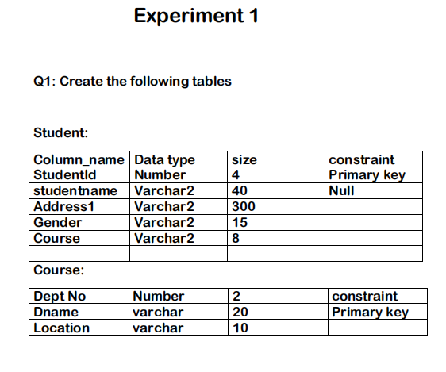

**STUDENT TABLE:**

CREATE TABLE Student

( StudentId NUMBER(4) PRIMARY KEY,

StudentName VARCHAR2(40) NOT NULL,

Address1 VARCHAR2(300),

Gender VARCHAR2(15),

Course VARCHAR2(8) );

**COURSE TABLE:**

CREATE TABLE Course

( CourseID VARCHAR2(12) PRIMARY KEY,

DeptNo NUMBER(2),

Dname VARCHAR2(20),

Location VARCHAR2(10) );

1. **Insert five records for each table.**

**Student Table:**

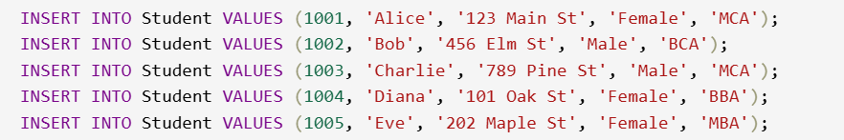

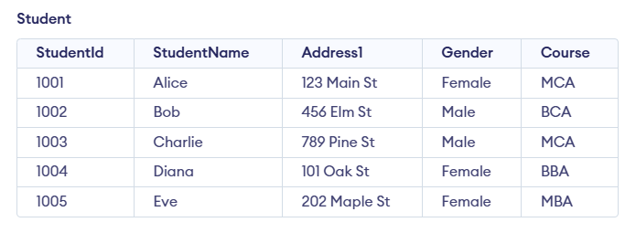

**Course Table:**

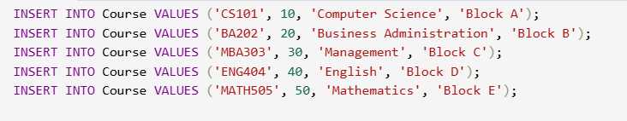

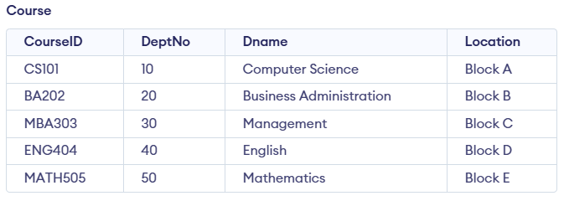

1. **List all information about all students from student table.**



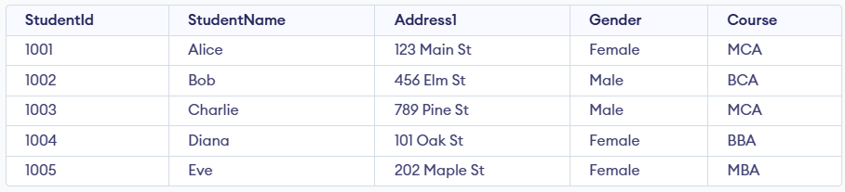

1. **List all student numbers along with their courses.**



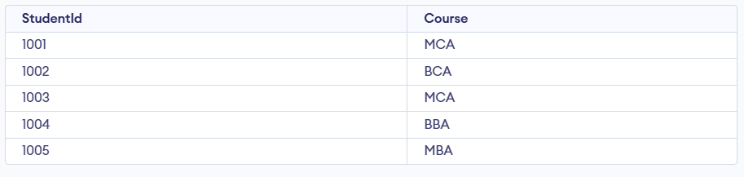

1. **List Dname and locations from the Course table.**



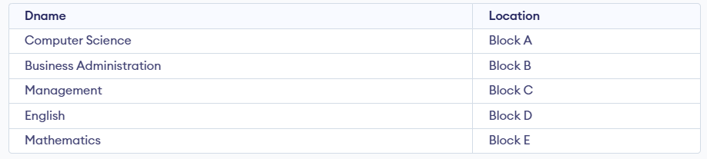

1. **List the details of students in the MCA course**



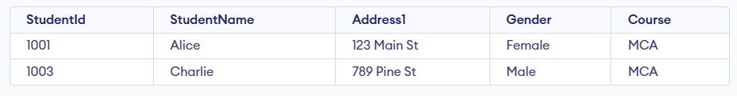

1. **List names of employees (students) not belonging to department 10, 40**



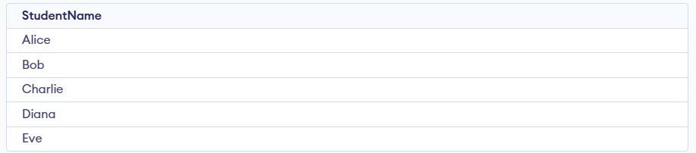

1. **List employees whose names start with "S" (not "s")**





1. **List employees ending with name "s"**





1. **List the students details in ascending order of course**



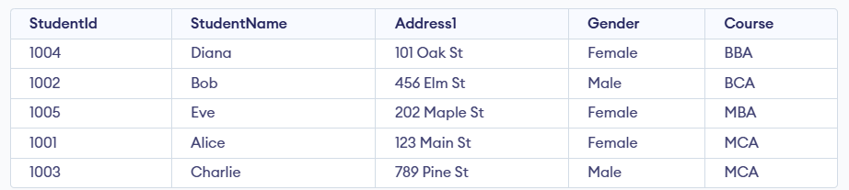

1. **List the number of Students in BCA course.**





1. **List the number of students available in student table.**





1. **Create a table with a primary key constraint.**

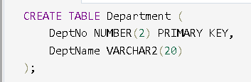

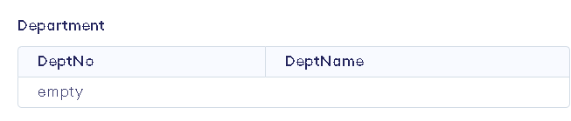

1. **Create a table with all column having not null constraints.**

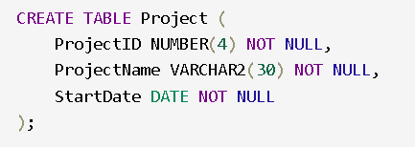

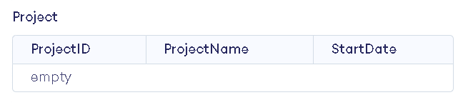

1. **Create a foreign key constraint in a table**

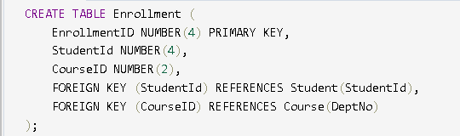

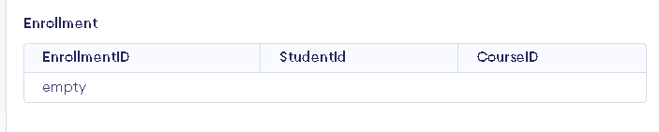

1. **Create a Table with a unique key constraint.**

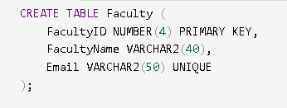

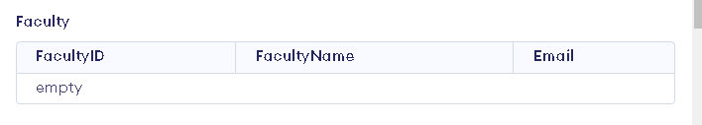

1. **Display list of student ordered by course.**

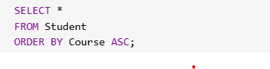

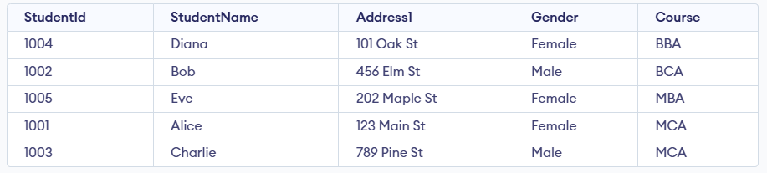

1. **Display alphabetically sorted list of students.**

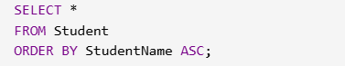

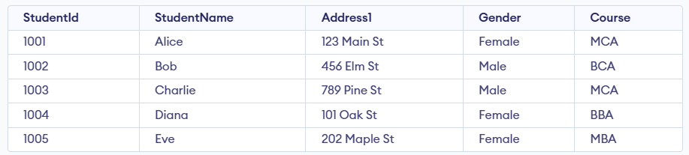

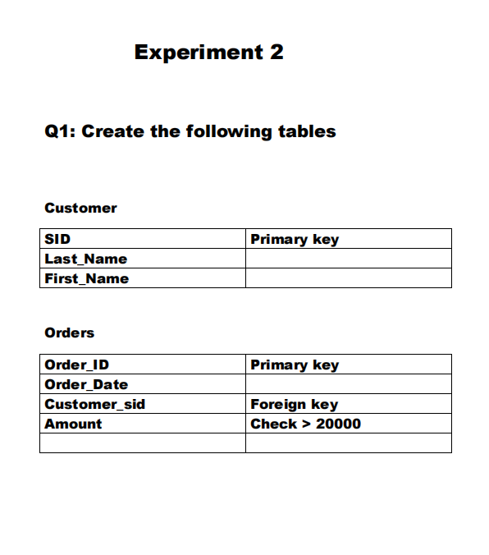

1. **Insert five records for each table.**

**Customer table**

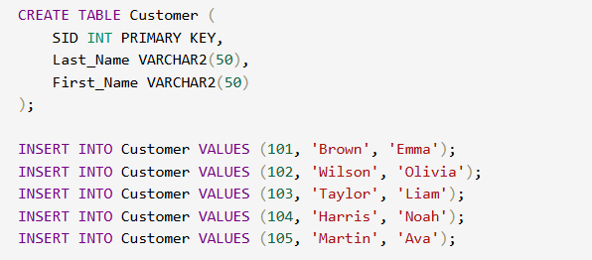

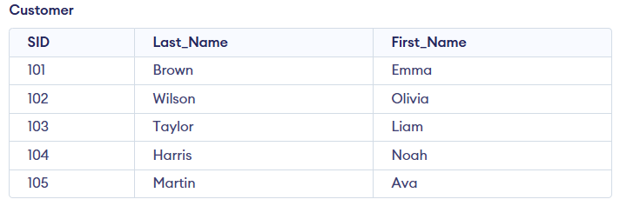

**Orders table**

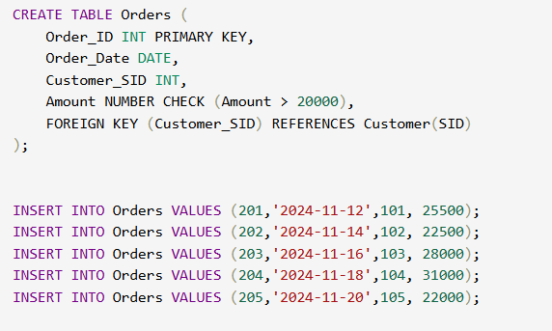

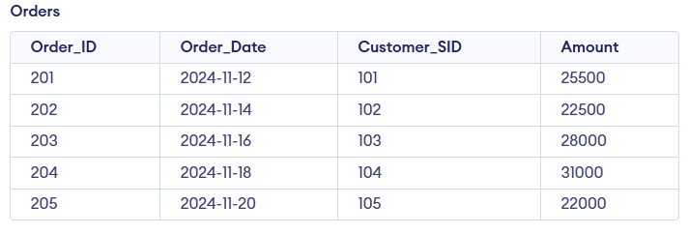

1. **List the details of the customers along with the amount.**

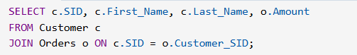

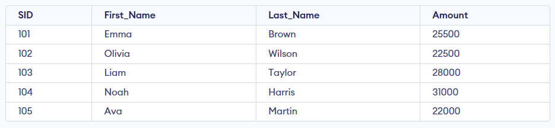

1. **List the customers whose names end with "s".**





1. **List the orders where the amount is between 21000 and 30000.**



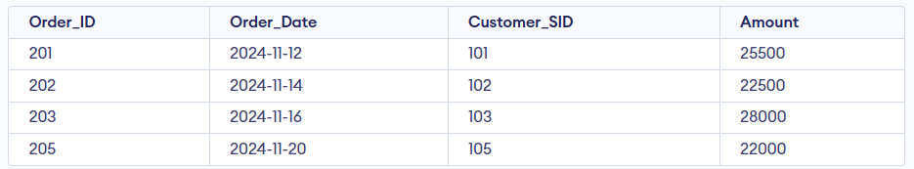

1. **List the orders where the amount is increased by 500 and replace with name "new amount".**



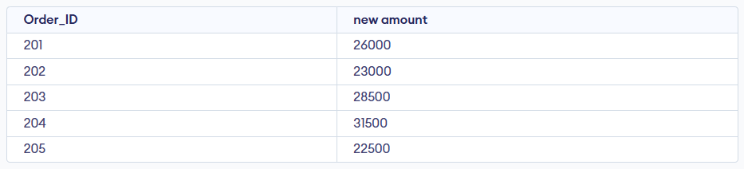

1. **Display the order_id and total amount of orders.**



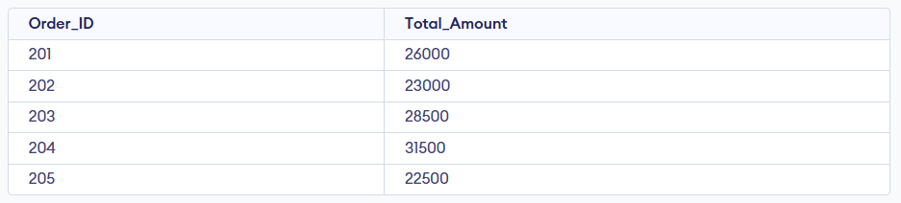

1. **Calculate the total amount of orders that has more than 15000.**





1. **Display the left join function.**

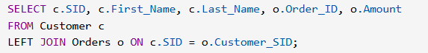

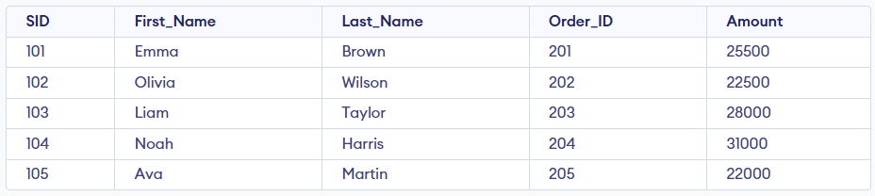

1. **Display the right join function.**

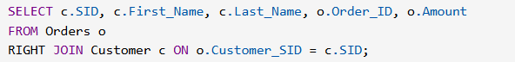

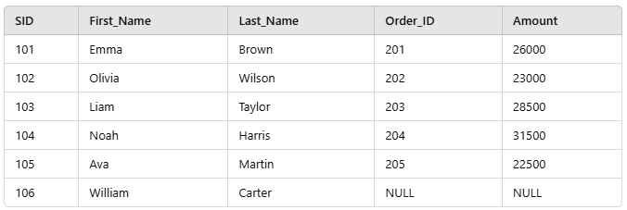

1. **Display the outer join function.**

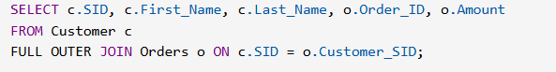

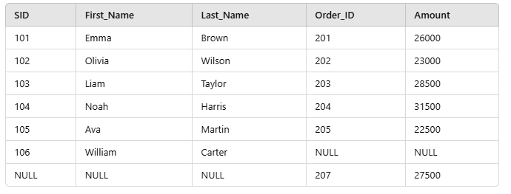

1. **Display the inner join function.**

